**THE IIS UNIVERSITY**

MAJOR PROJECT PRESENTATION

MCA-621



**A Project Report on**

**National Crusher Manufacturing Company**

Submitted for partial fulfillment for award of the degree in

**Master of Computer Application (MCA)**

**Submitted by:** **Guided by:**

Ms. Harsh Kanwar Mr. Manoj Kumar

**THE IIS UNIVERSITY**



**DECLERATION BY THE CANDIDATE**

I hereby declare that the project entitled, “NATIONAL CRUSHER MANUFACTURING COMPANY” is a bonafide genuine research work carried out by us under the guidance of Mr. Manoj Kumar.

Harsh Kanwar

Place: Jaipur

Date: 17/05/2019

**EFFORTS BY:**

Harshita Virwani

Sonali Temani

Anshita Mathur

**ACKNOWLEDGEMENT**

The satisfaction that accompanies that the successful completion of any task would be incomplete without the mention of people whose ceaseless cooperation made it possible, whose constant guidance and encouragement crown all efforts with success on the topic National Crusher Manufacturing Company.

We must convey our gratitude towards to Mr. Manoj Kumar for giving us the constant source of inspiration and help in preparing the project, personally correcting our work and providing encouragement throughout the project.

We also thank all our faculty members for steering us through the tough as well as easy phases of the project in the result-oriented manner with concern attention.

We would also like to thank our parents and friends who helped us a lot in finishing this project within the limited time. We have indeed learnt a lot from this project about working in groups.

Harsh Kanwar

**TABLE OF CONTENTS**

**CONTENTS PAGE NO.**

**1. PROJECT SPECIFICATION 7-8**

**1.1 Project Overview 7**

**1.2 Objective 7**

**1.3 Project Need 8**

**2. SPECIFIC REQUIREMTS 9**

**2.1Hardware Interface 9**

**2.2 Software Interface 9**

**2.3 Security 9**

**3. SOFTWARE PRODUCT FEATURES 10-14**

**3.1 ER Diagram 10**

**3.2Data Flow Diagram (Level 0) 11**

**3.3 Data Flow Diagram (Level 1) 12**

**3.3User Interfaces 13**

**3.4 Testing Technologies 14**

**4. LIMITATIONS 14**

**5. PROPOSED ENHANCEMENTS 14**

**6. CONCLUSION 15**

**7. REFRENCES AND BIBLOIOGRAPHY 15**

**8. ANNEXURE**

**8.1 User Interface Screen 16-31**

**8.2 Data Base Screen Shots 32-34**

**8.3 Program Code 35-10**

**PROJECT SPECIFICATIONS**

**PROJECT OVERVIEW:**

* The National Crusher Manufacturing Company is an informational website to provide information to the customers.
* National crusher provide capabilities for customers to enquiry about particular Product, Sub Product, Services which they like.
* Our site provide the visitors view count through chart on month and yearly basis for better understanding.
* It provide an attractive look for customers and admin.
* Admin can add new Product, Sub Product, Services and Photos which makes National crusher site dynamic.
* Admin sends mail to the customers in response to the enquiry from the admin panel.
* The aim of this project is to make an attractive, responsive, dynamic informational website to attract many customers belongs to different states.
* Admin can view the enquiry forms given by the customers on the dashboard.
* According to the visitor ratio, charts are generated for better visibility and understanding.
* Customer’s identity is hidden from admin till the customer don’t fill the enquiry form.

**OBJECTIVES:**

The Main Objective of the National crusher site is to manage the details of Products, Sub products, Services and Gallery for Admin. Only Admin is guaranteed access for any update or insert or delete of any information or record. Customer can just view the information provided by admin and can enquiry for the same. The purpose of this project is to make an attractive, responsive and dynamic informational site that can attract customers from different places.

* Decision making power is provided to admin by this system.
* Accurate viewers can be obtained.
* This system makes product and services presentation more effective.
* Can reply customer enquiry anywhere anytime

**PROJECT NEED**

* The need of this project is to give the control to admin so that whenever he wants he can change in the content anytime, anywhere.
* It will ensure more business opportunities for company.
* The company should know about the customer queries.
* This is also useable for the viewer ratio evaluation, which generates the accurate result in optimum time.

**EXISTING SYSTEM:**

* In the existing site admin have no control, no dynamicity.
* Not so attractive and responsive.
* No visitor viewer ratio track.

DISADVANTAGES FOR EXISTING SYSTEM

* The existing system is static, updated in years.
* It does not attract much customers.
* No admin control.

**PROPOSED SYSTEM:**

* In the proposed system, i.e. National crusher site eliminates the limitations of existing system.
* National crusher site consist of 2 Users:

1. Admin
2. Customer

* In this system, customer enquiries are collected online from the customers.
* It provides visitor view ratio track.
* It is a quick and easy way to attract more customers of different places.

**System Modules:**

1. *Admin*:

* Admin logins to the system with valid user id and password.
* Admin adds new Product, Sub product, Services and Pictures in the System.
* Admin can reply of enquiry from the admin panel which directly goes to the mail id of customer provided by them on enquiry form.
* Admin can insert, update, and delete records from the database*.*
* Admin maintains the record of all Product, Sub product and services.
* Admin can view visitor view ratio on through chart.
* Admin have visitor view ratio chart on monthly and yearly basis.
* Admin can also update in their profile and can manage their gallery.

1. *Customers*:

* Customers are important users for the system.
* Customers can selects product and on the basis of that they will able to see the sub products related to the selected product.
* Customer can enquiry for the product, sub product, services anything in the enquiry form.

**SPECIFIC REQUIREMENTS**

**HARDWARE INTERFACE**

* Processor**:** Pentium III 630MHz and Above
* Hard Disk: 500 GB and Above.
* RAM: 1 GB and Above

**SOFTWARE INTERFACE**

* Operating System: Windows 98, Windows XP, Windows7 and above
* Server-Side Technology: ASP.Net
* Database Server: Microsoft SQL Server
* Client-Side Scripting: JavaScript and jQuery
* Designing Language: HTML, CSS and Bootstrap
* Programming Language: C#

**SECURITY MECHANISM**

* For security purpose, login page is designed with login ID and Password of Admin so that no unauthorized user can login to the system and can access any confidential data.
* In case admin forget the password there is forget password mechanism through which admin can change their password.
* There is validation on enquiry form and new product ,sub product, services and picture registration form and in their edit as well.

**SOFTWARE PRODUCT FEATURE**

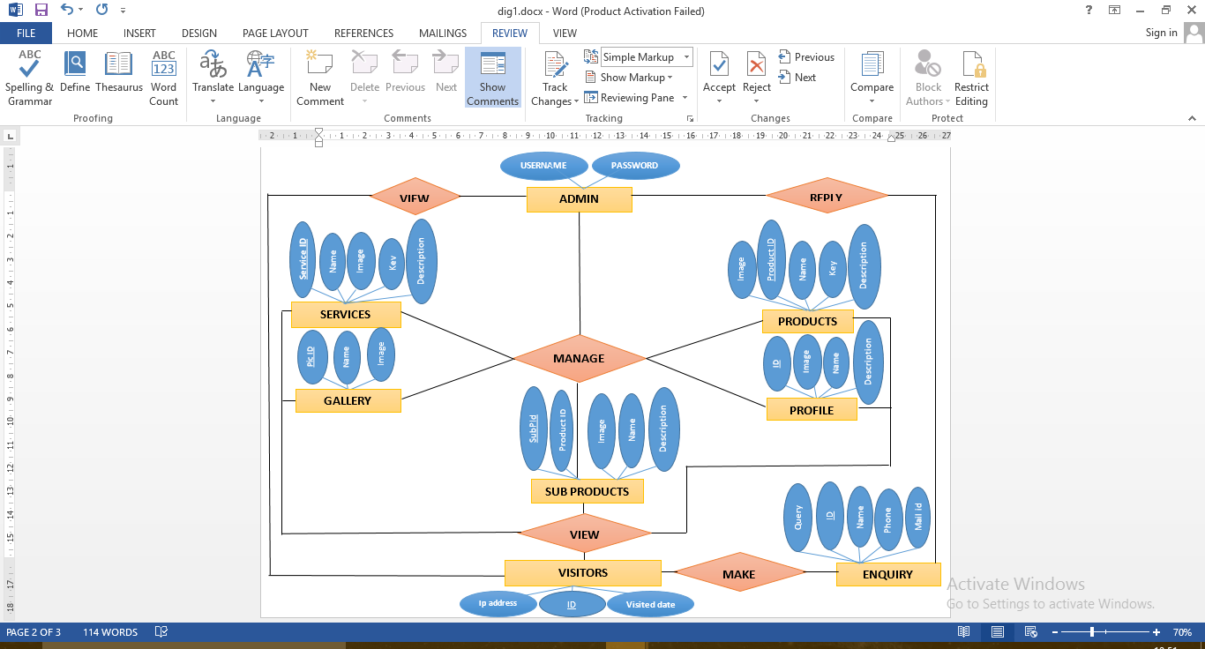**ER DIAGRAM**

**DFD LEVEL 0**

VISITOR

ADMIN

Login

MANAGES

(ADD/UPDATE/DELETE/VIEW)

REPLY ENQUIRES

LOGOUT

VIEW

(PRODUCT/SERVICES/GALLERY)

ENQUIRY

**DFD LEVEL 1**

**ADMIN**

**Login**

1

**Products**

2

**Sub Product**

3

**Services**

4

**Gallery**

5

**Profile**

6

**VISITOR**

**Enquiry**

7

**Visitors**

8

Login Details

Username/Password

Sends Information

(Insert/update/delete)

(Insert/update/delete)

(Insert/update/delete)

(Insert/update/delete)

(Insert/update/delete)

**USE CASE**

**USER**

**ADMIN**

**TESTING TECHNOLOGIES**

* **Functionality Testing:**

Testing for all the links in web pages, database connection, forms used for submitting or getting information from user in the web pages, etc.

* **Database testing:**
* Check for data integrity and errors while admin edit, delete, modify the forms or do any Database related functionality.
* Check if all the database queries are executed correctly, data is retrieved and updated correctly.
* **Validation Testing:**
* **All the Controls are validated according to specific validations needed.**
* **If any validation is not satisfied then an error message is displayed to the user.**
* **Interface Testing:**
* **Check if all the interactions between linked pages and database are executed and errors are handled properly.**

**LIMITATIONS**

* There is no feedback form for users.
* No rating criteria is there for customers.

**PROPOSED ENHANCEMENTS**

* Can manage the projects of company on the admin panel.
* Payment option can also be added when admin needed.

**CONCLUSION**

* The Proposed system is made to give the control to the admin.
* The system is useful for the visitor view ratio track.
* This system gives quick enquiries from the customers.
* Charts are given for better understanding of the visitor view ratio results.

**BIBLOGRAPHY**

* <https://www.youtube.com/>(For Grid View and Session Maintenance)
* <https://www.slideshare.net/>
* <https://www.tutorialspoint.com/asp.net/>

**USER INTERFACE SCREENS (SCREENSHOTS)**

**LOGIN PAGE FOR ADMIN:**

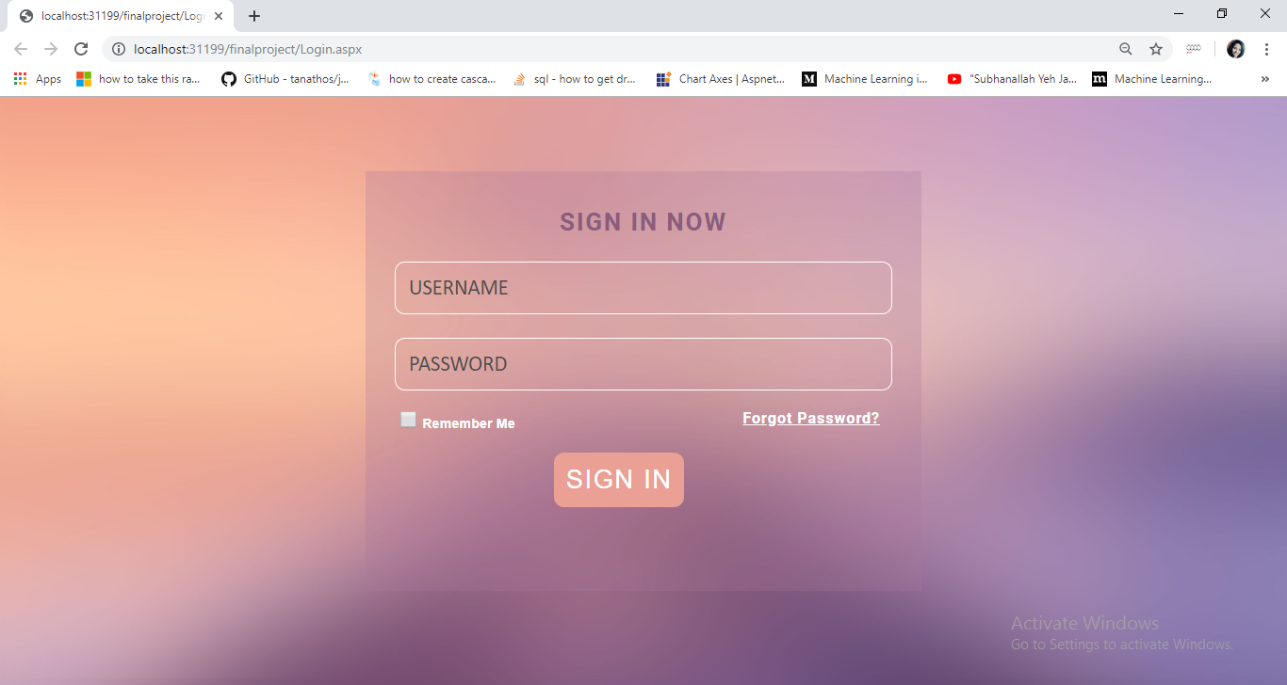

**FORGOT PASSWORD**

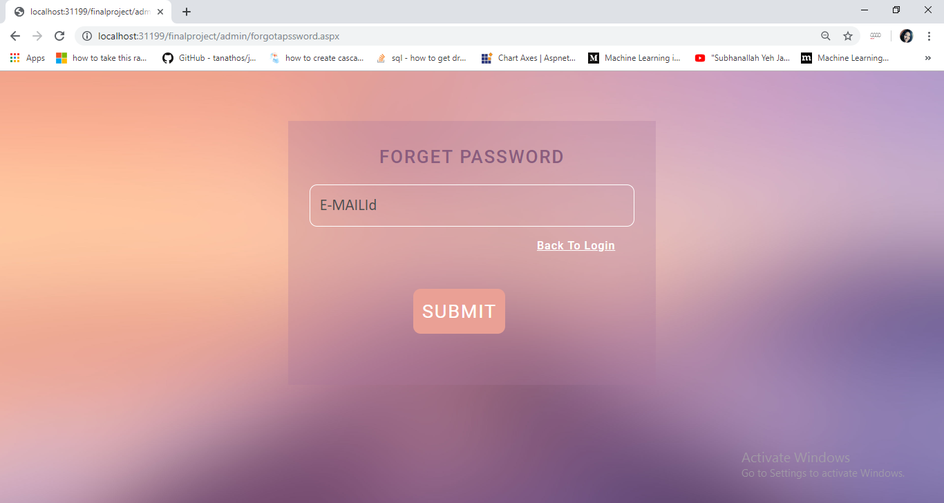

**RESET PASSWORD**

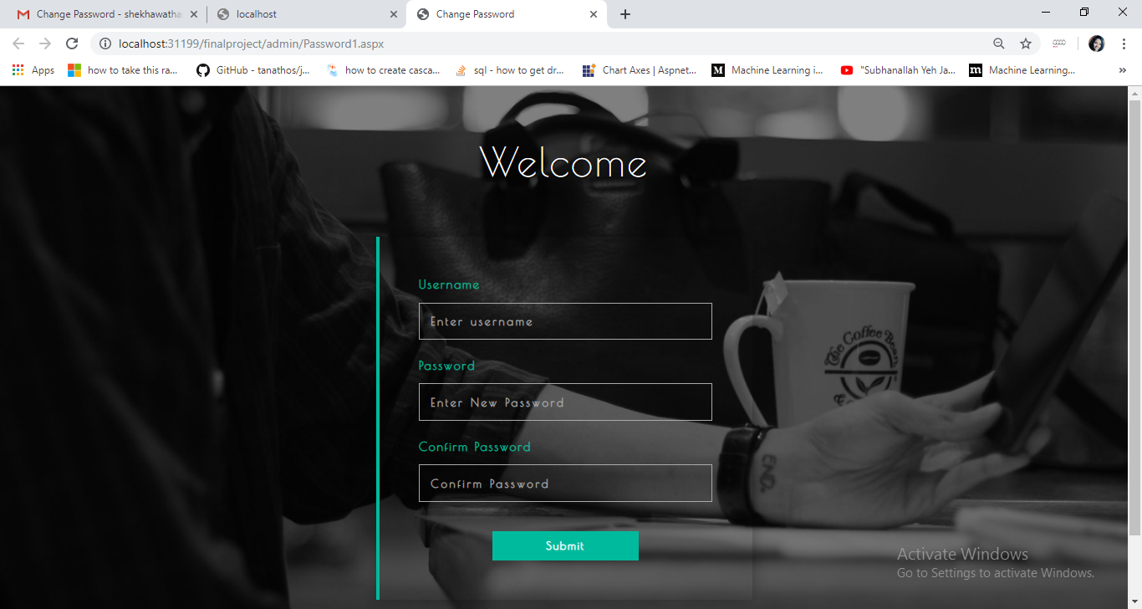

**ADMIN DASHBOARD**

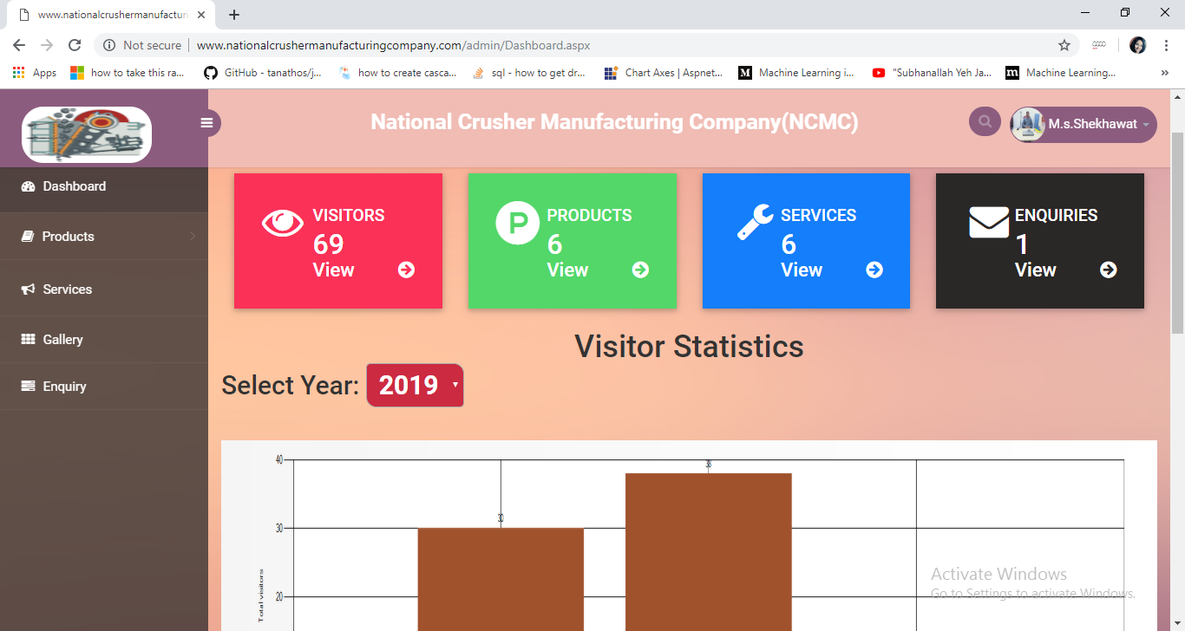

**MANAGE (ADD, UPDATE AND DELETE) PRODUCT DETAILS**

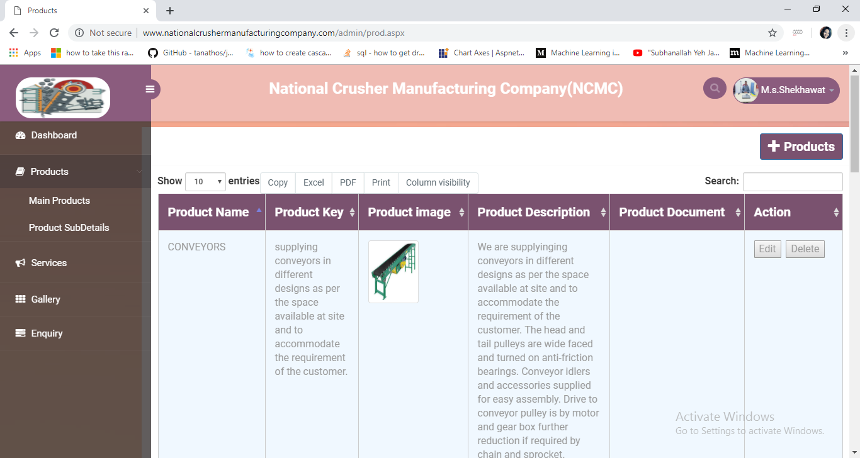

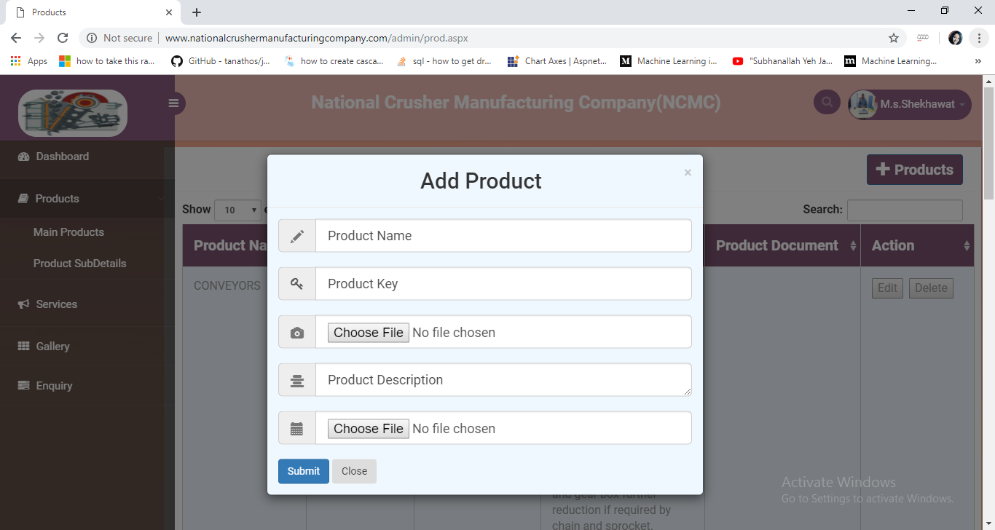

**MANAGE (ADD, UPDATE AND DELETE) SUB PRODUCT DETAILS**

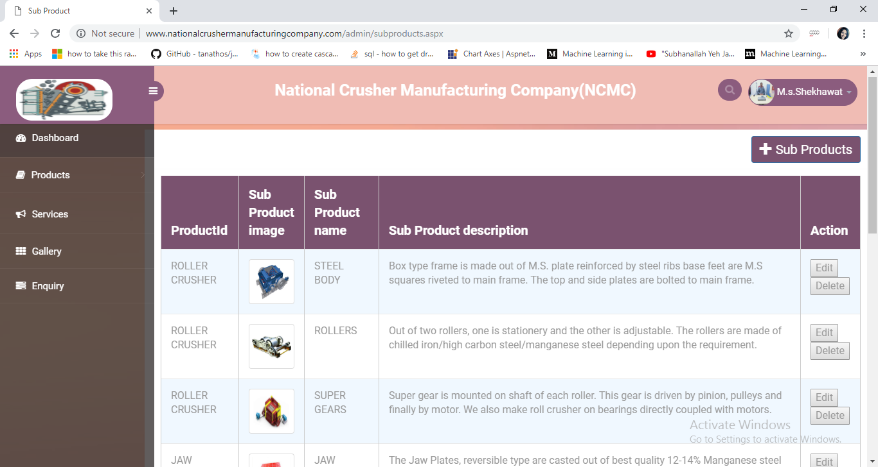

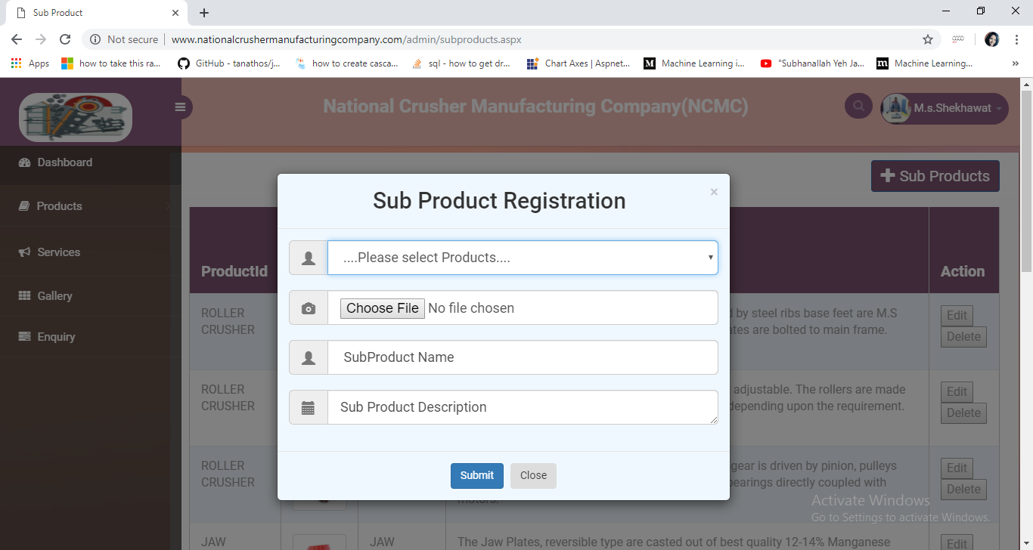

**MANAGE (ADD, UPDATE AND DELETE) SERVICES DETAILS**

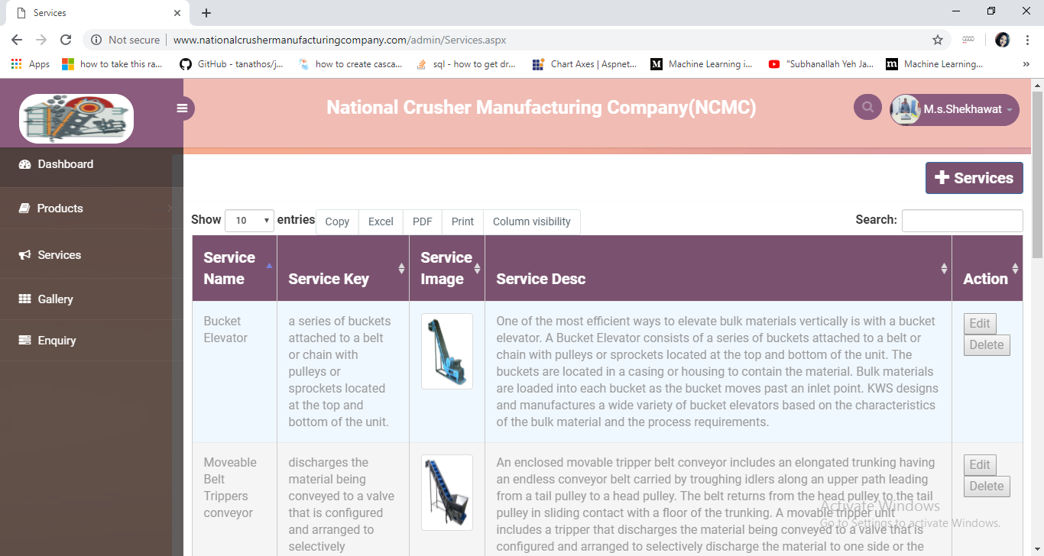

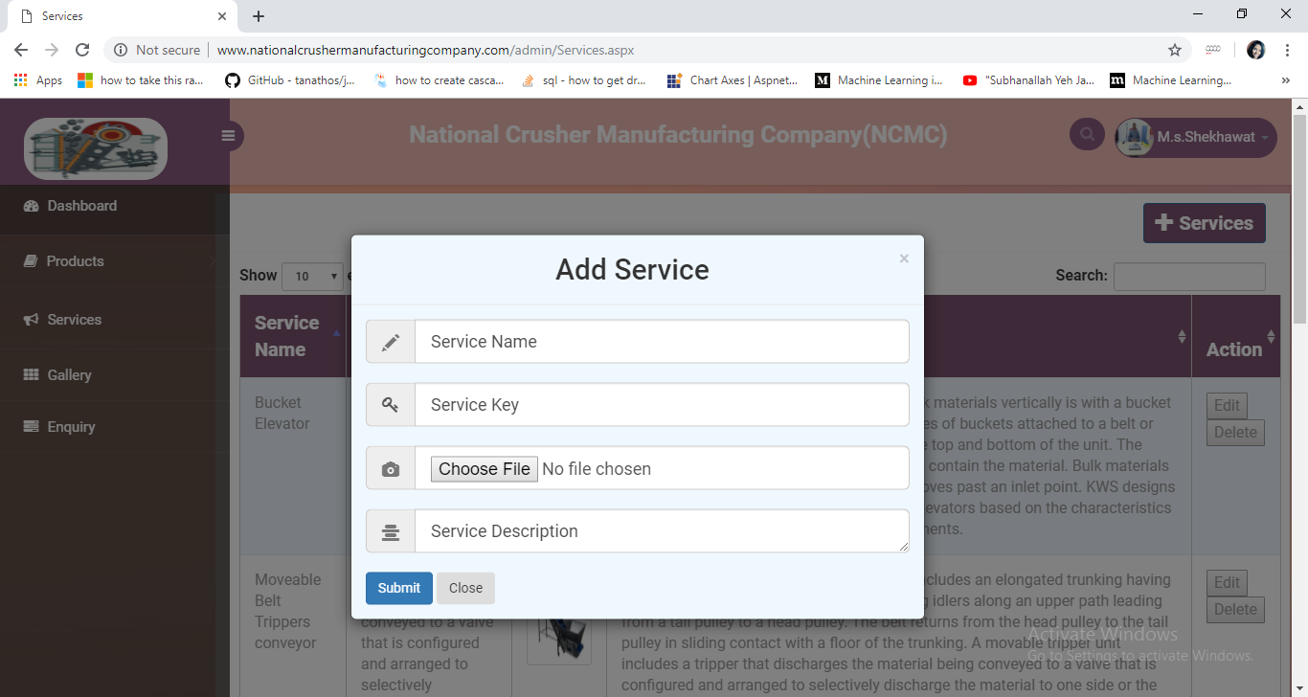

**MANAGE (ADD, UPDATE AND DELETE) GALERY DETAILS**

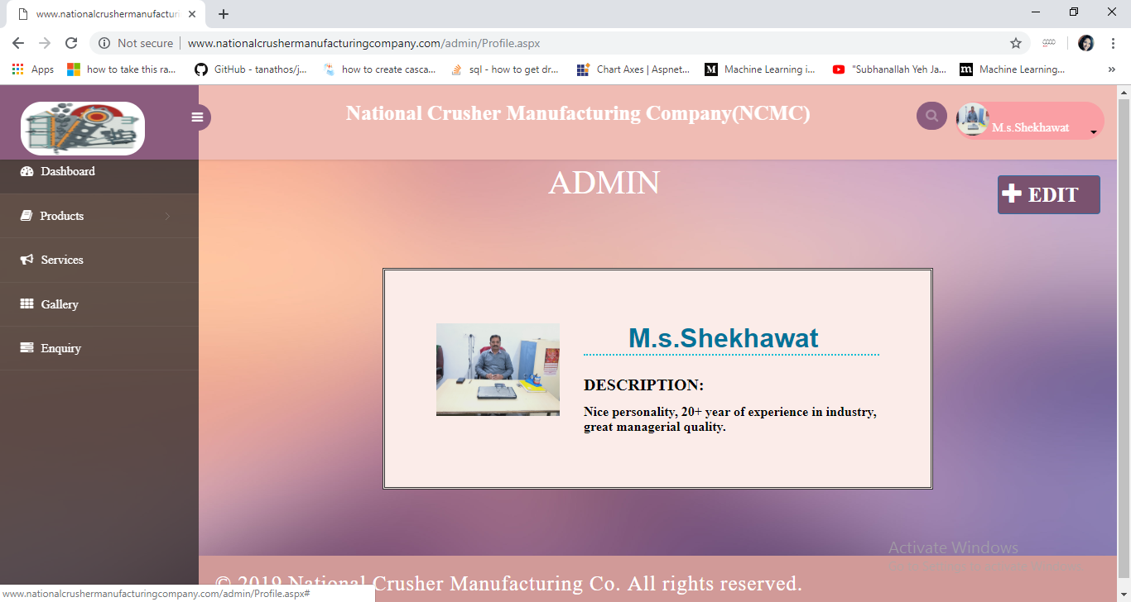

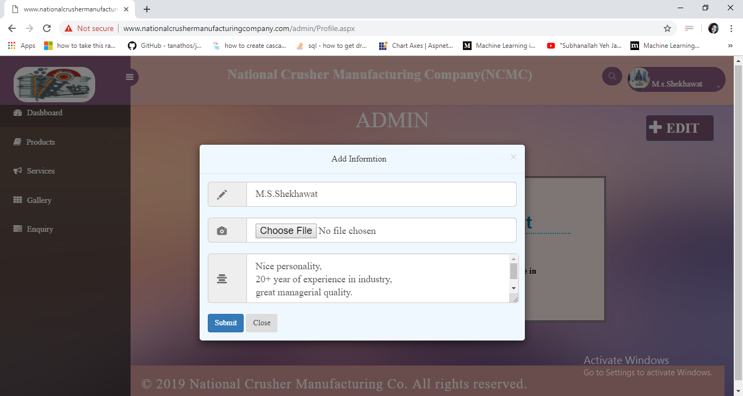

**USER HOME**

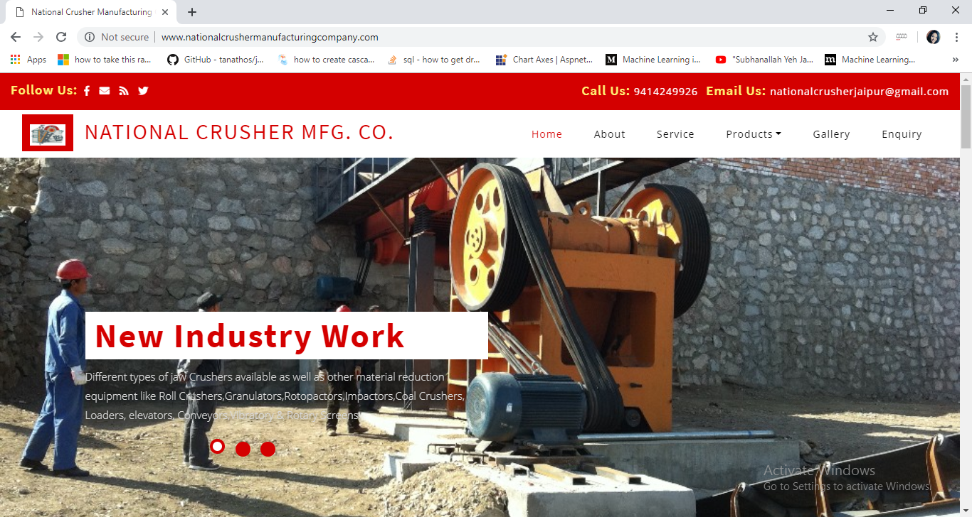

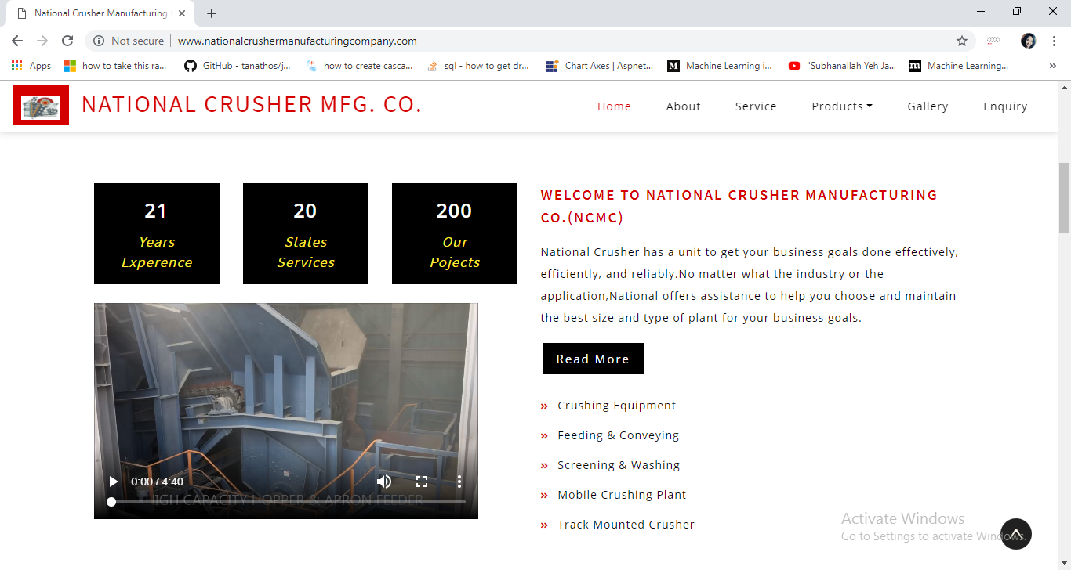

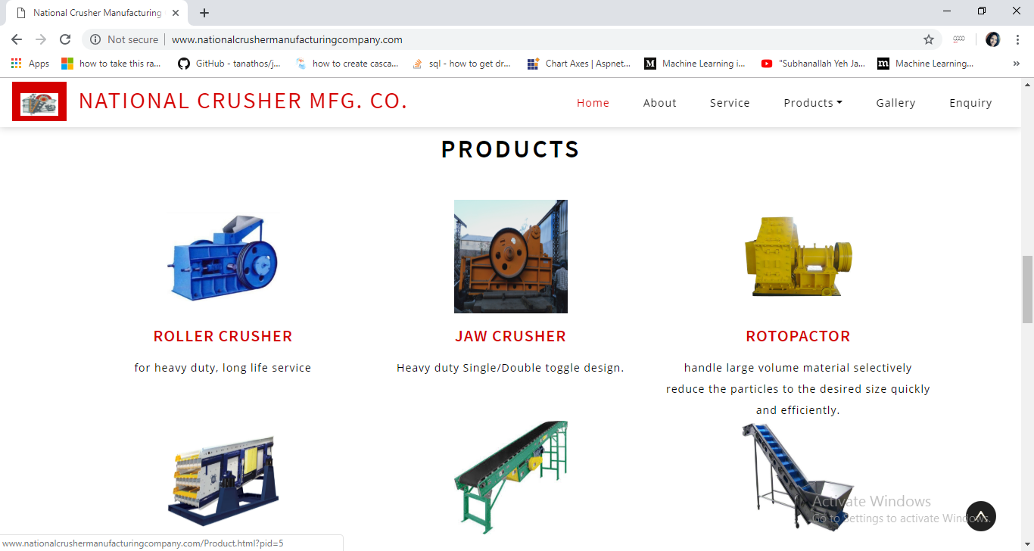

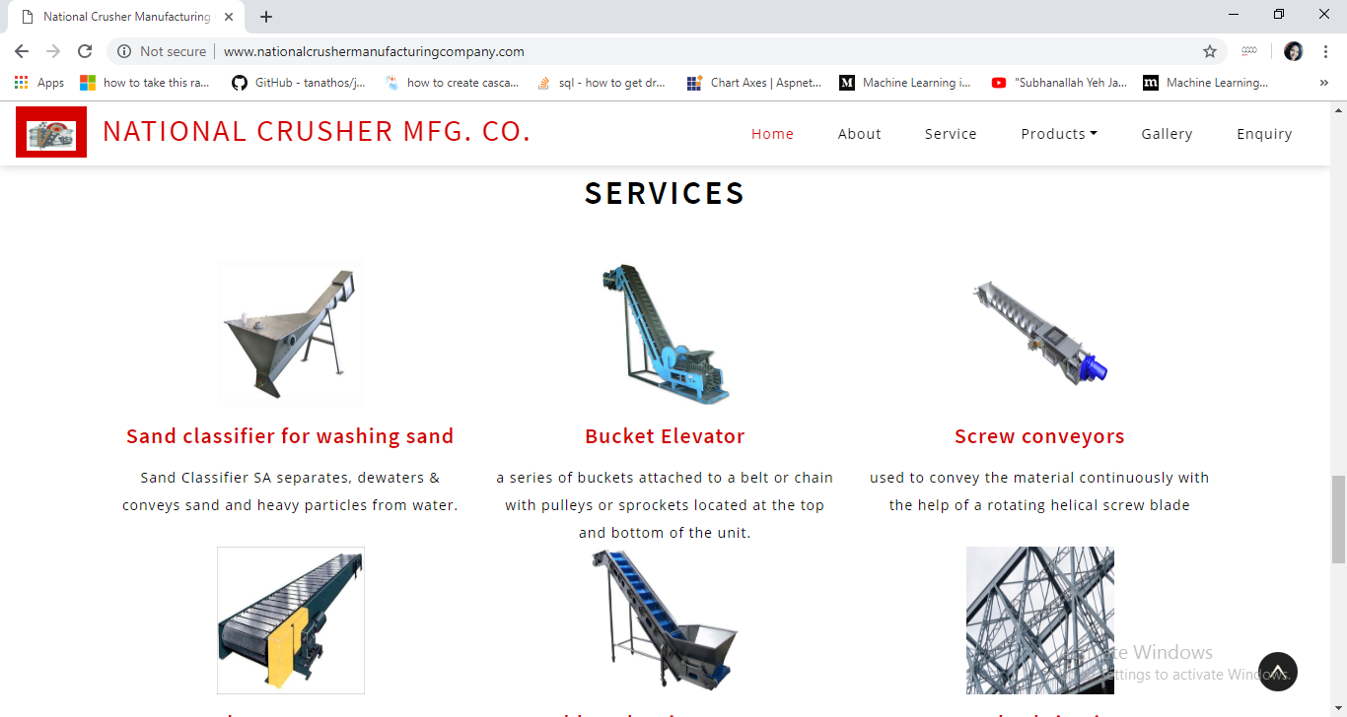

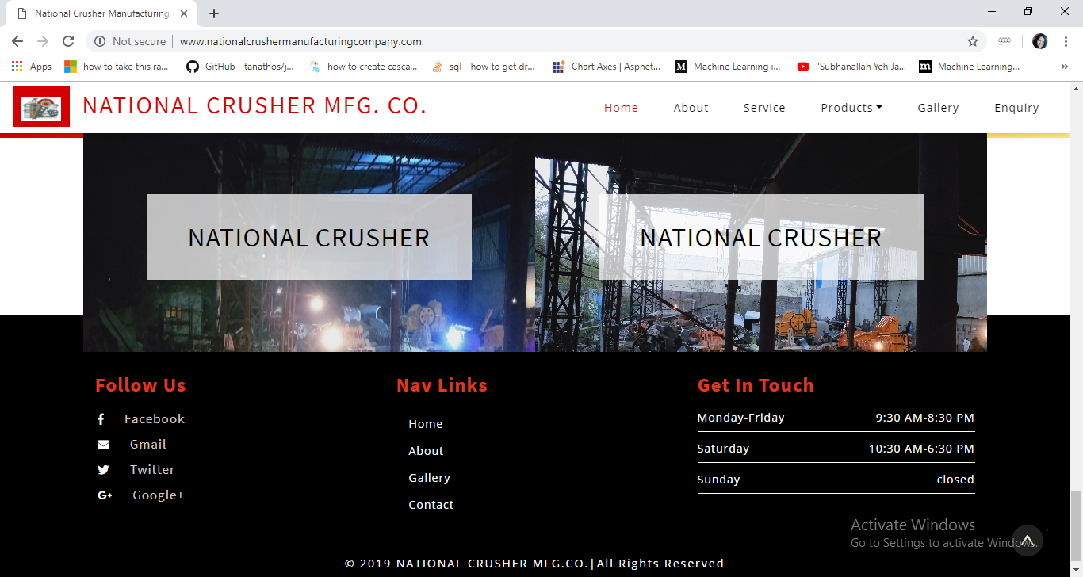

**ABOUT PAGE**

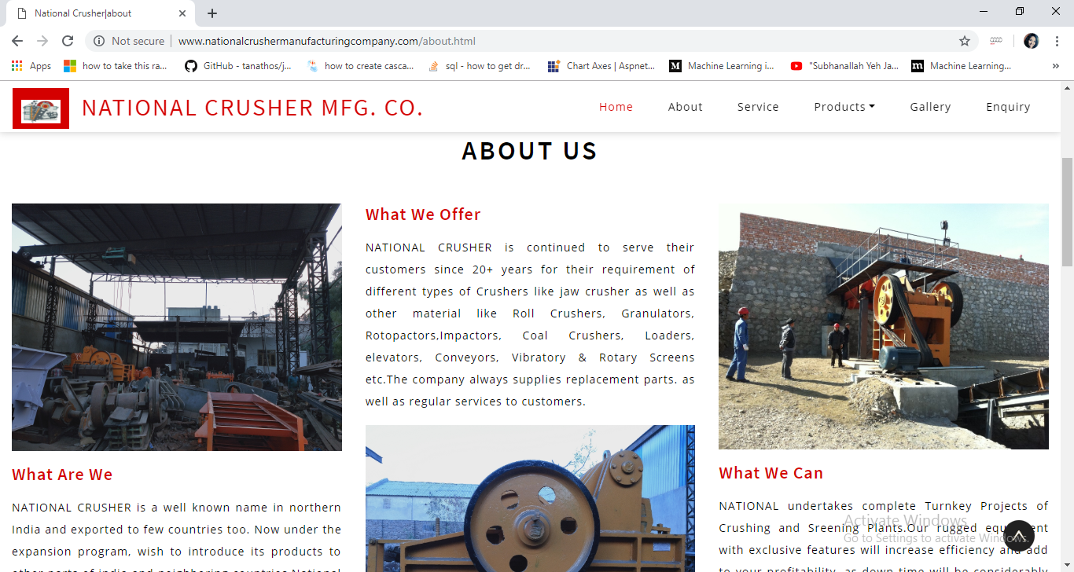

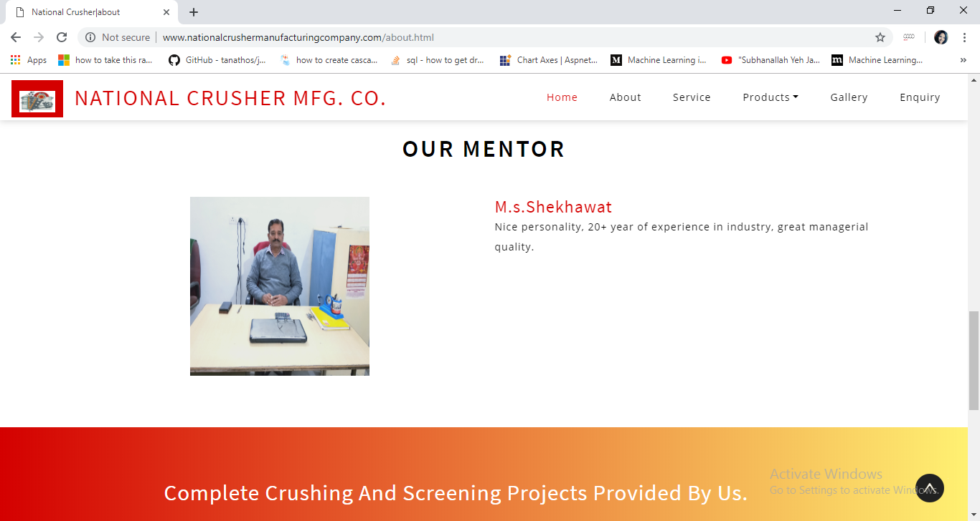

**SERVICE PAGE**

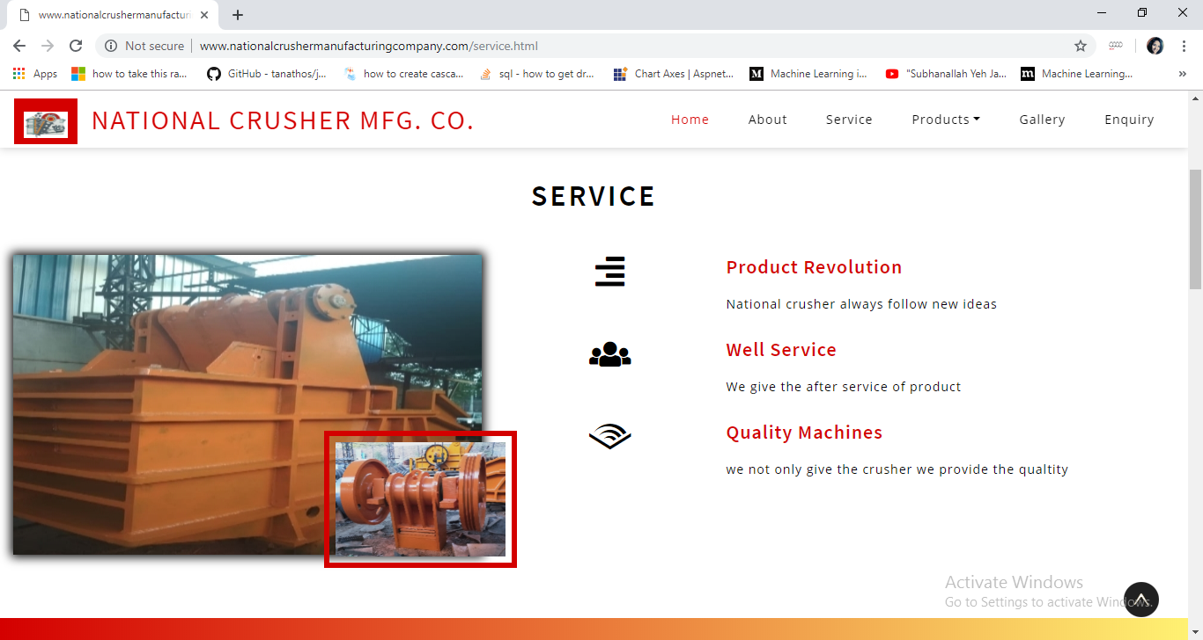

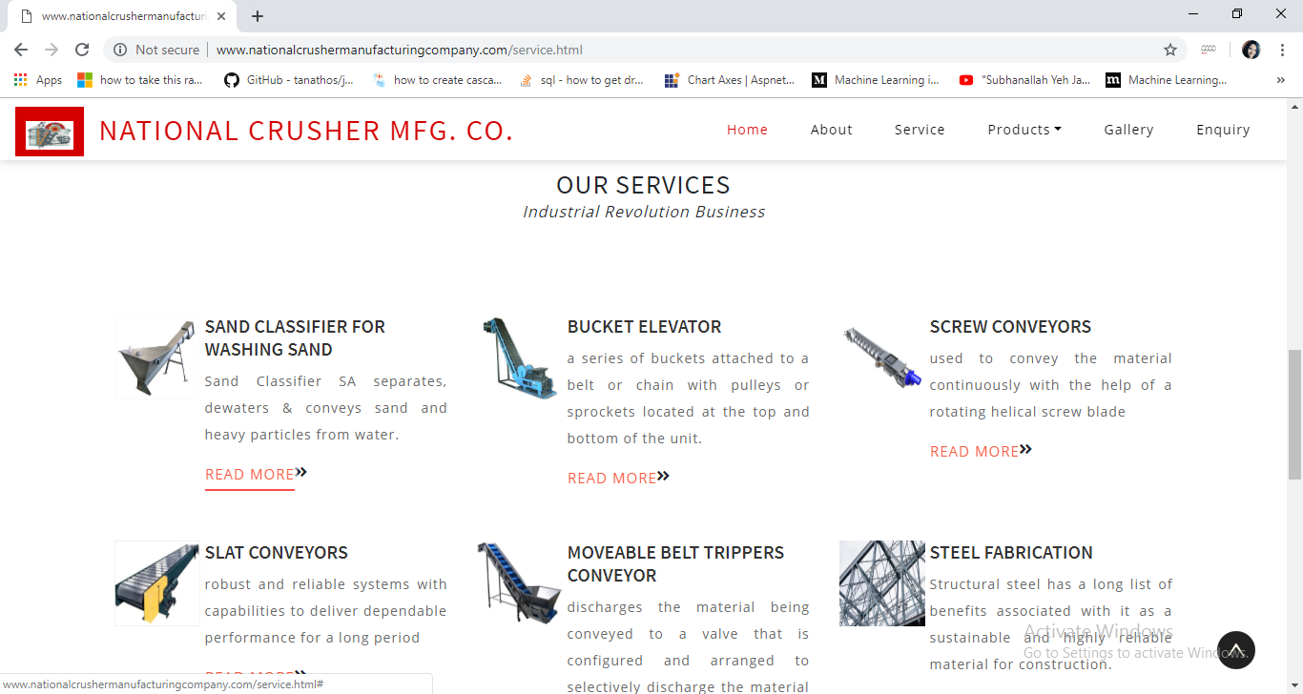

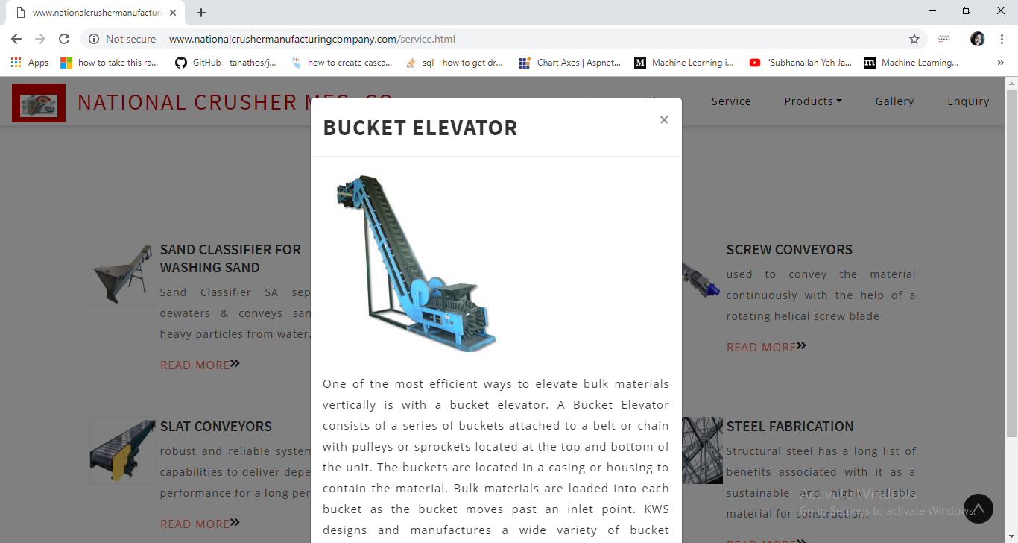

**PRODUCT PAGE**

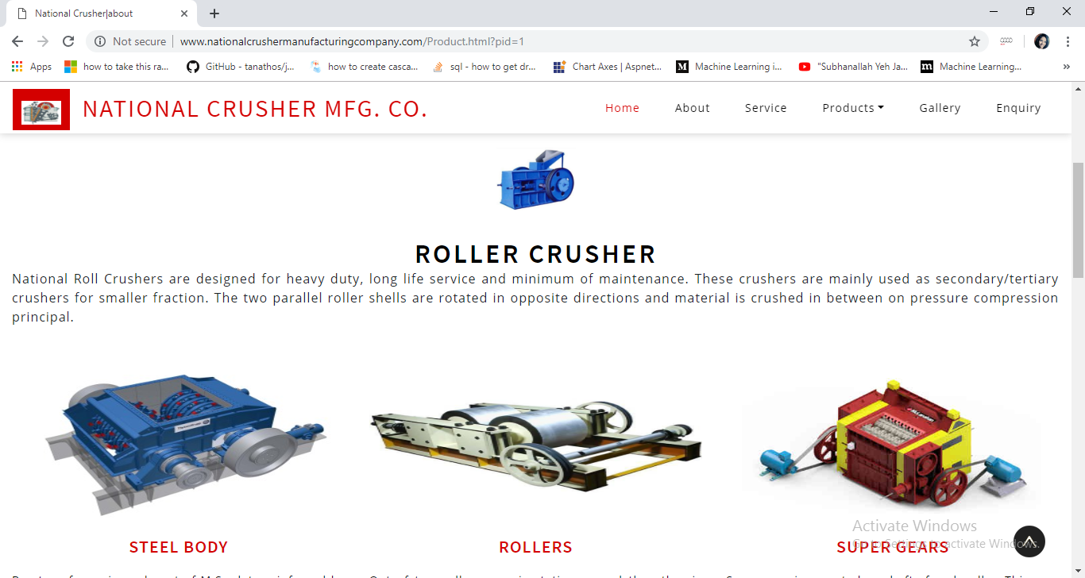

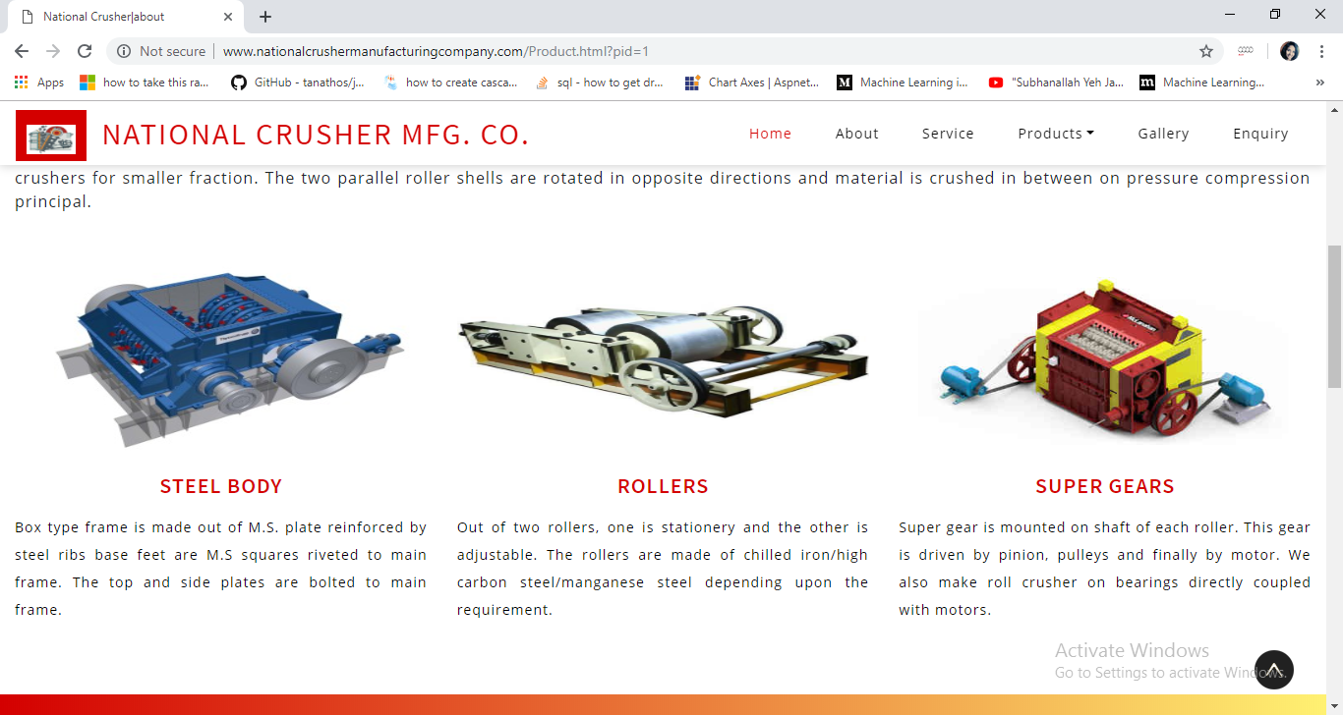

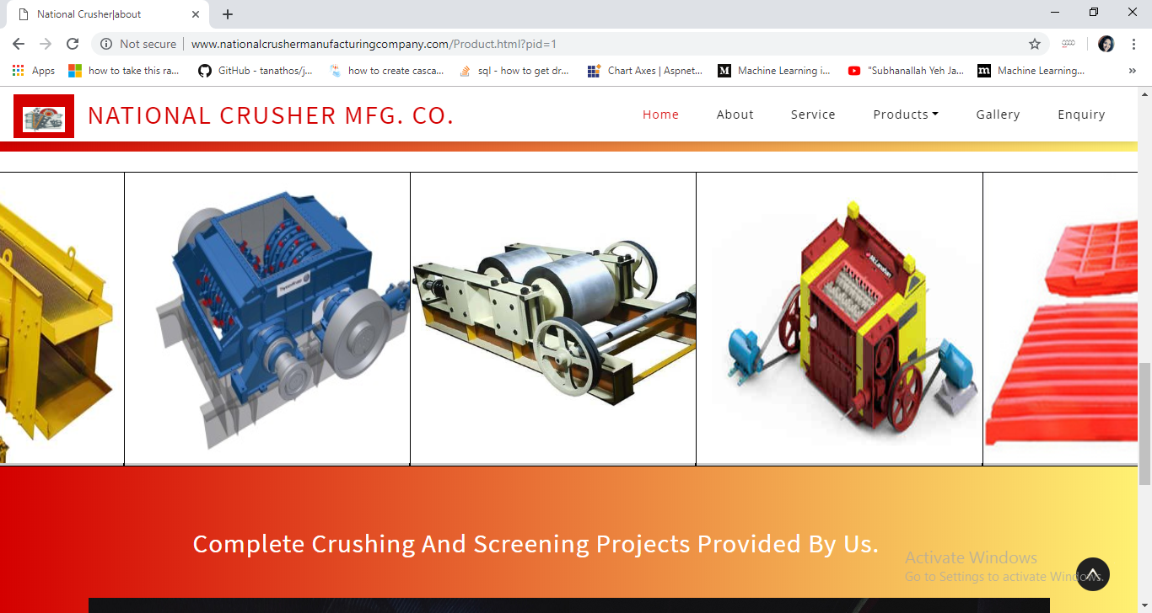

**GALLERY PAGE**

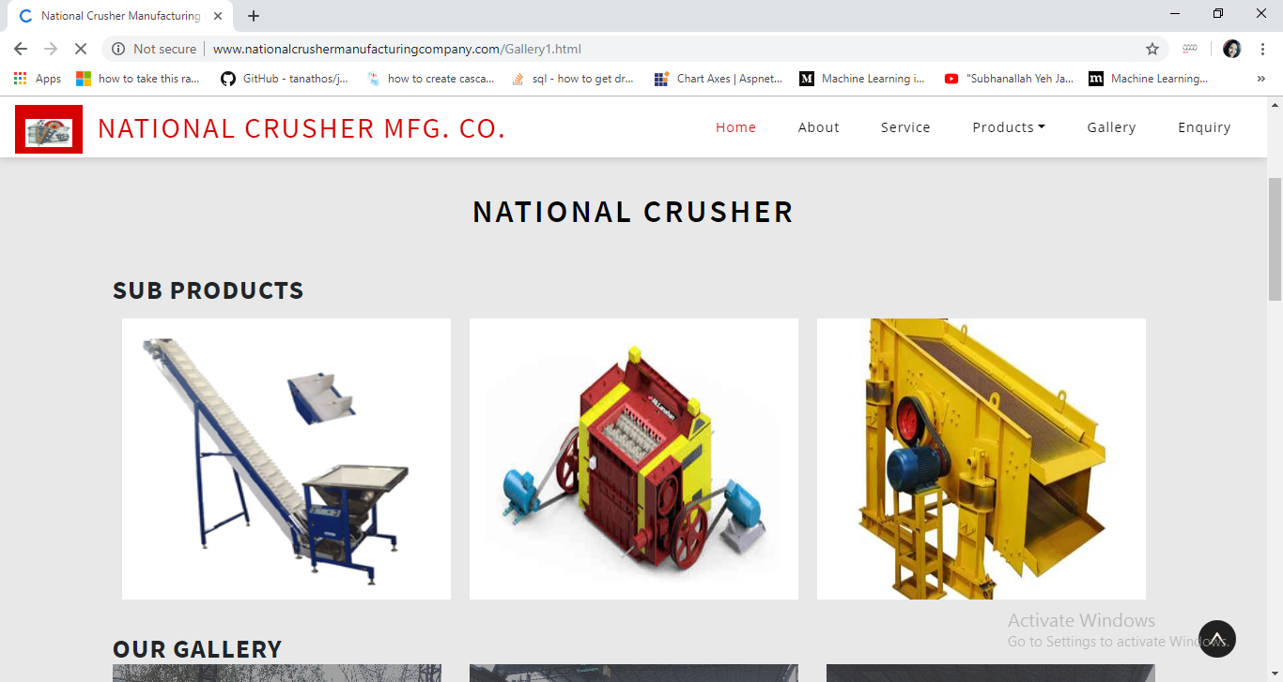

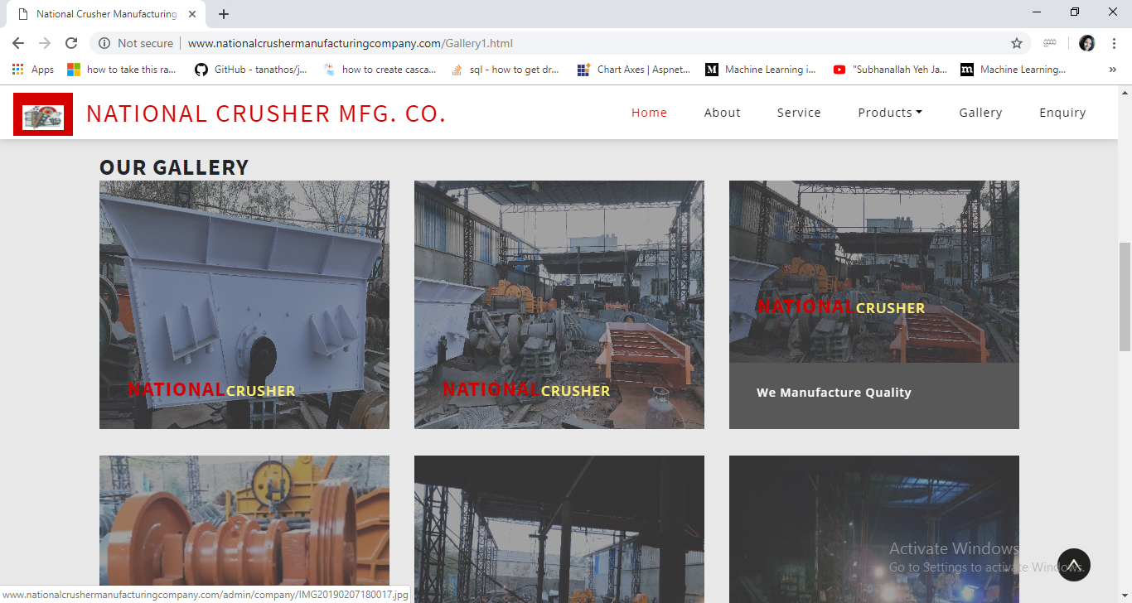

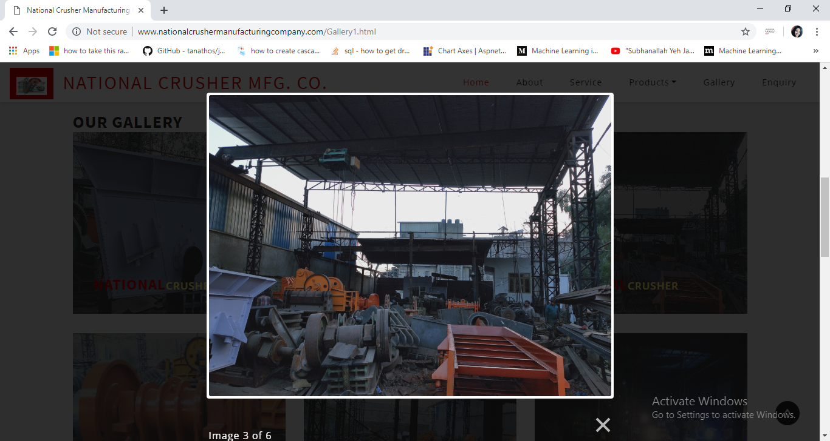

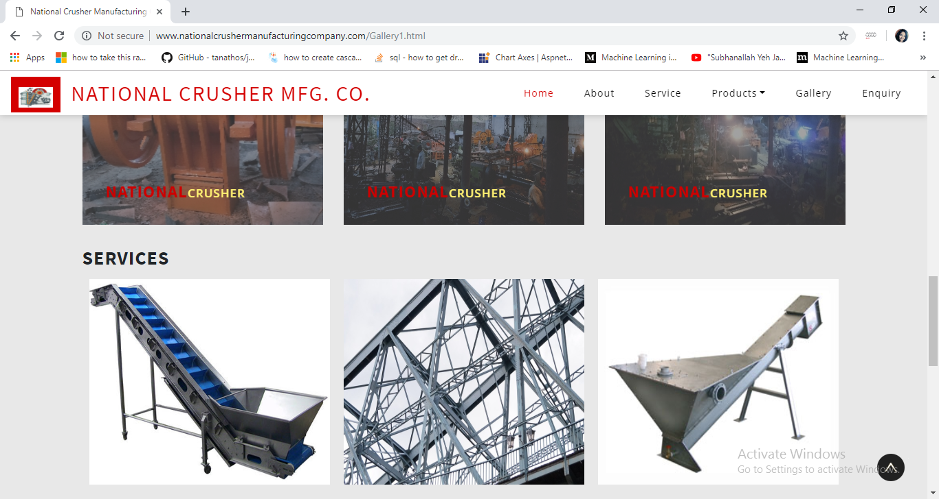

**ENQUIRY PAGE**

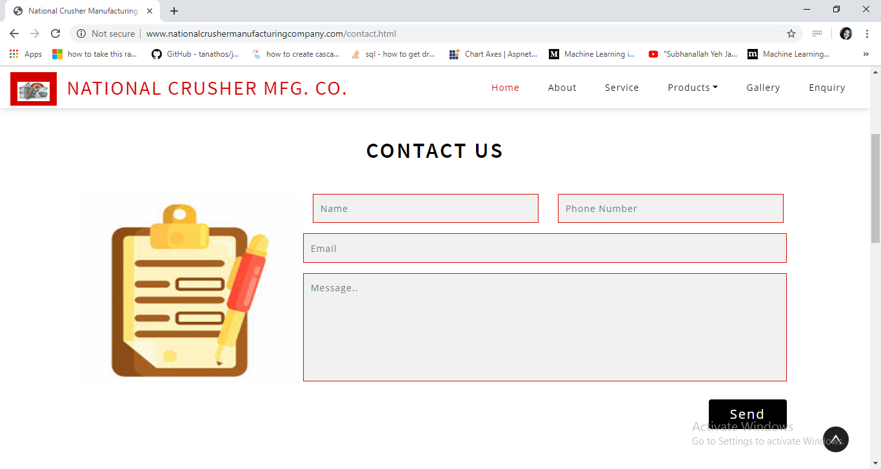

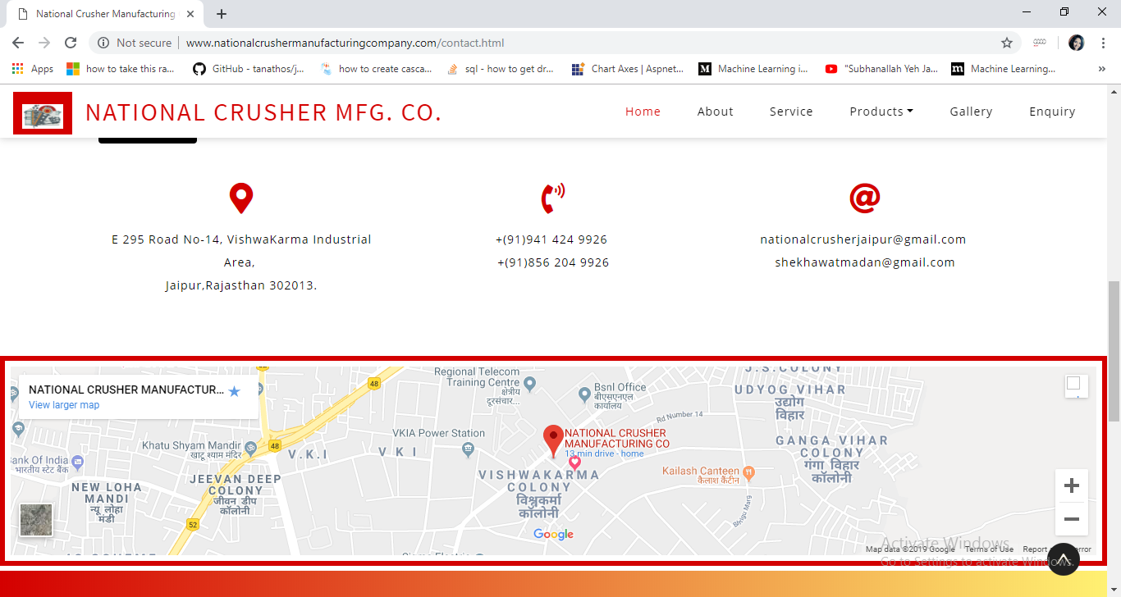

**DATABASE SCREENSHOTS**

**LOGIN**

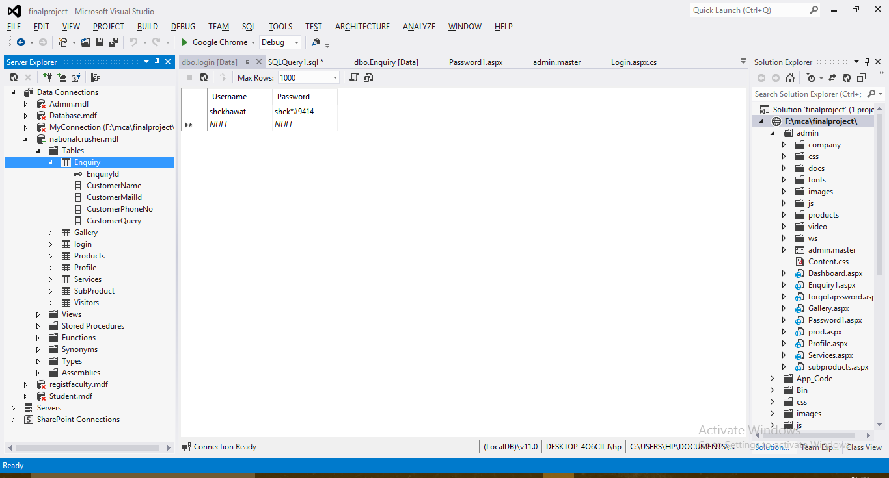

**PRODUCT**

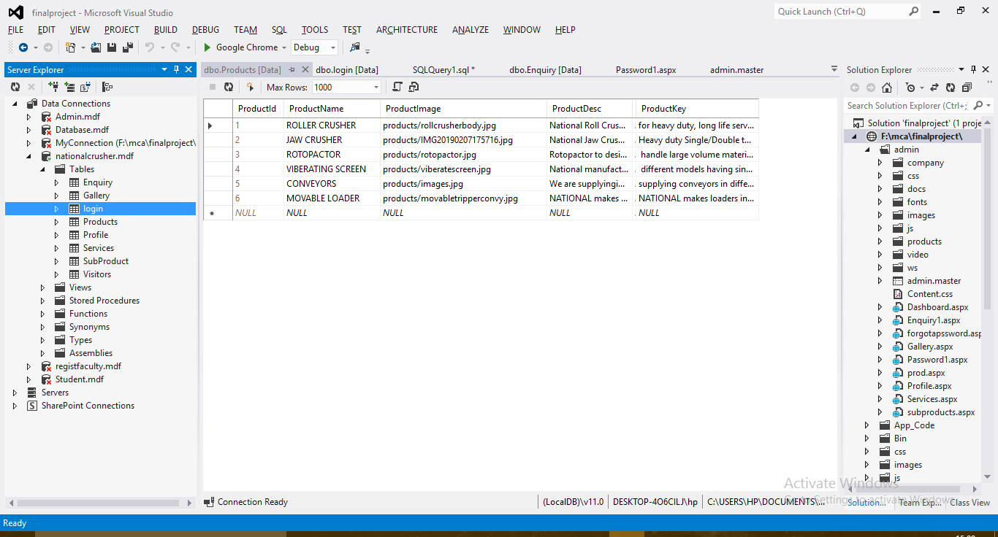

**ENQUIRY**

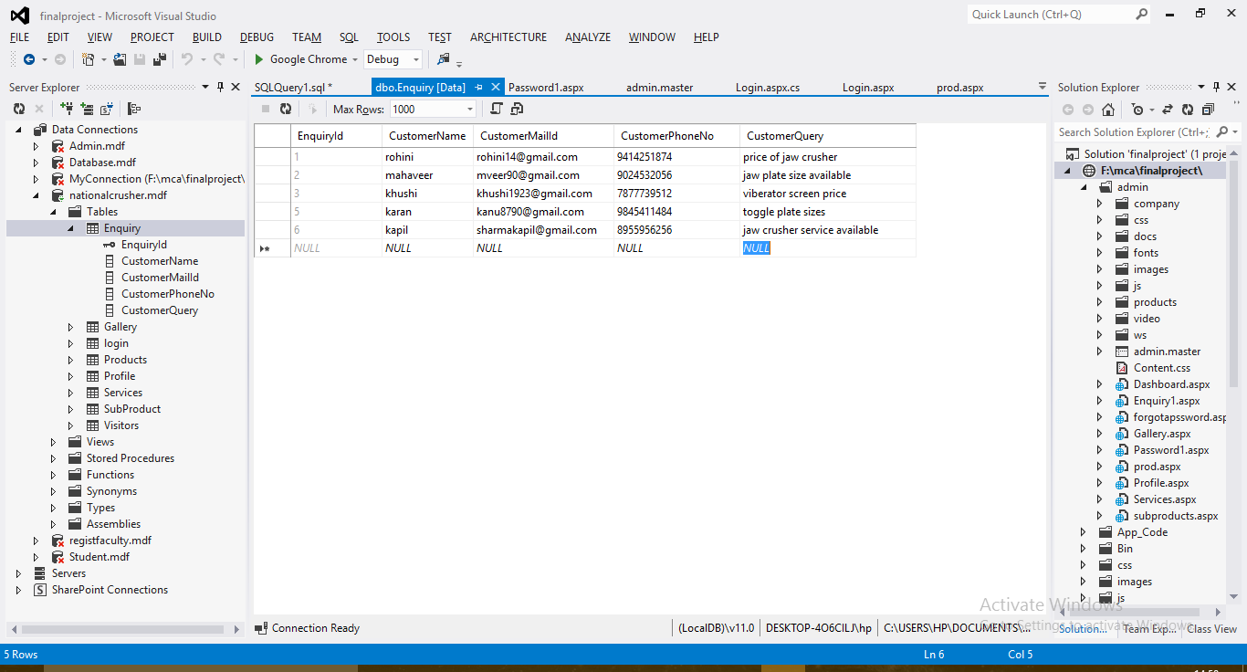

**SUB PRODUCT**

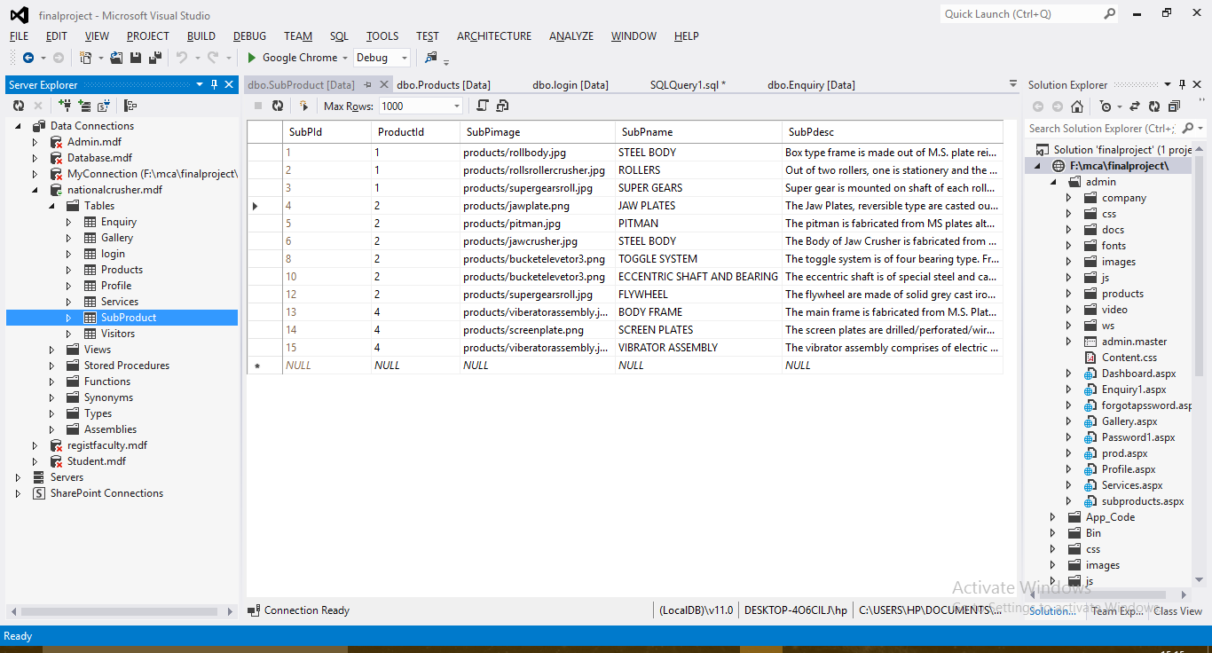

**SERVICES**

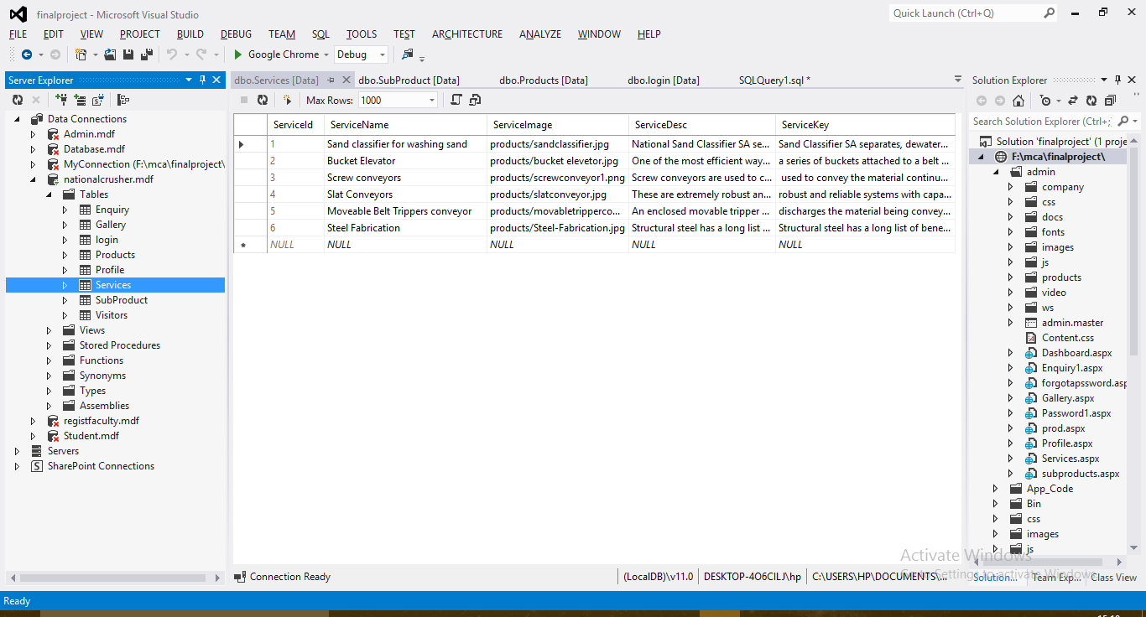

**GALLRY**

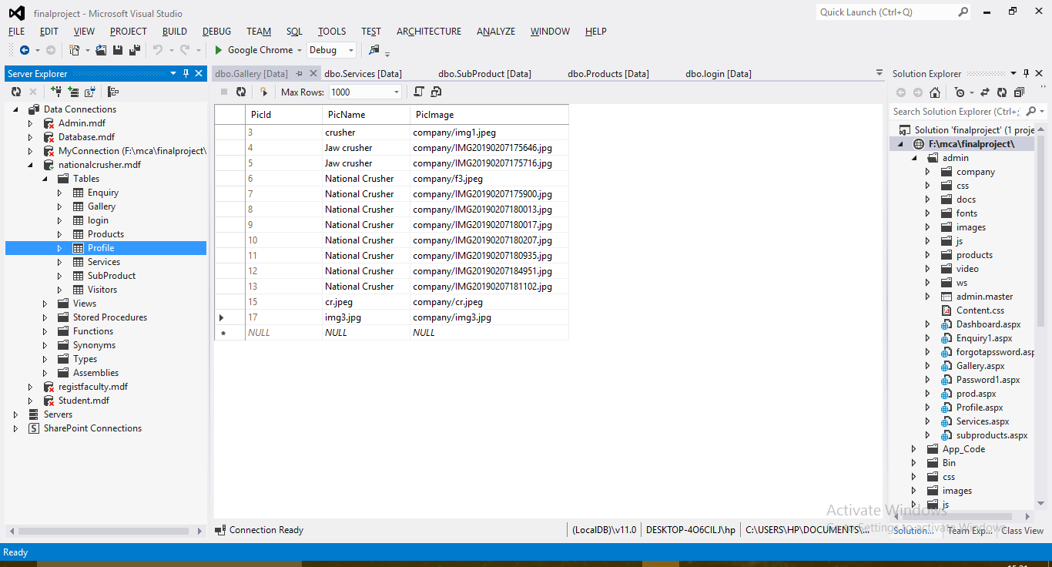

**VISITORS**

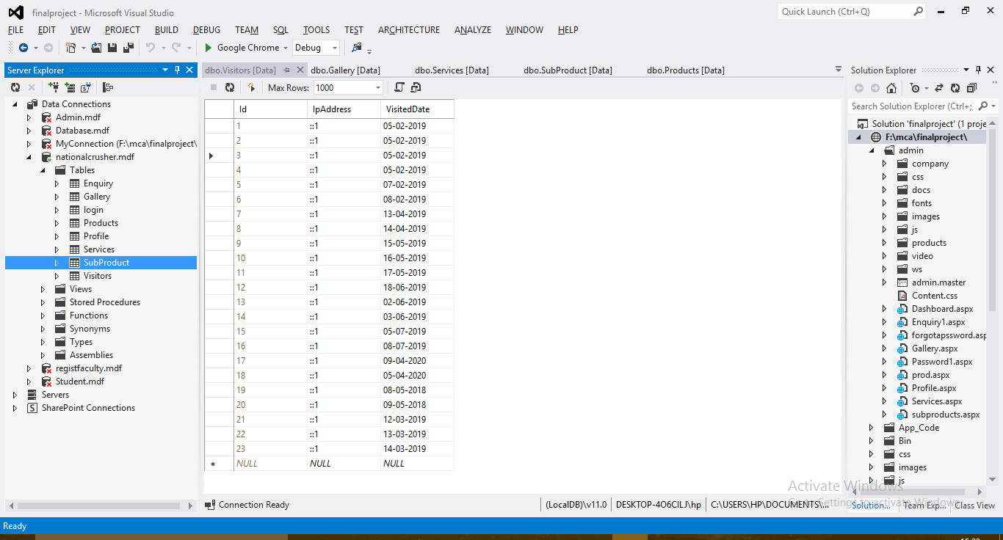

**PROFILE**

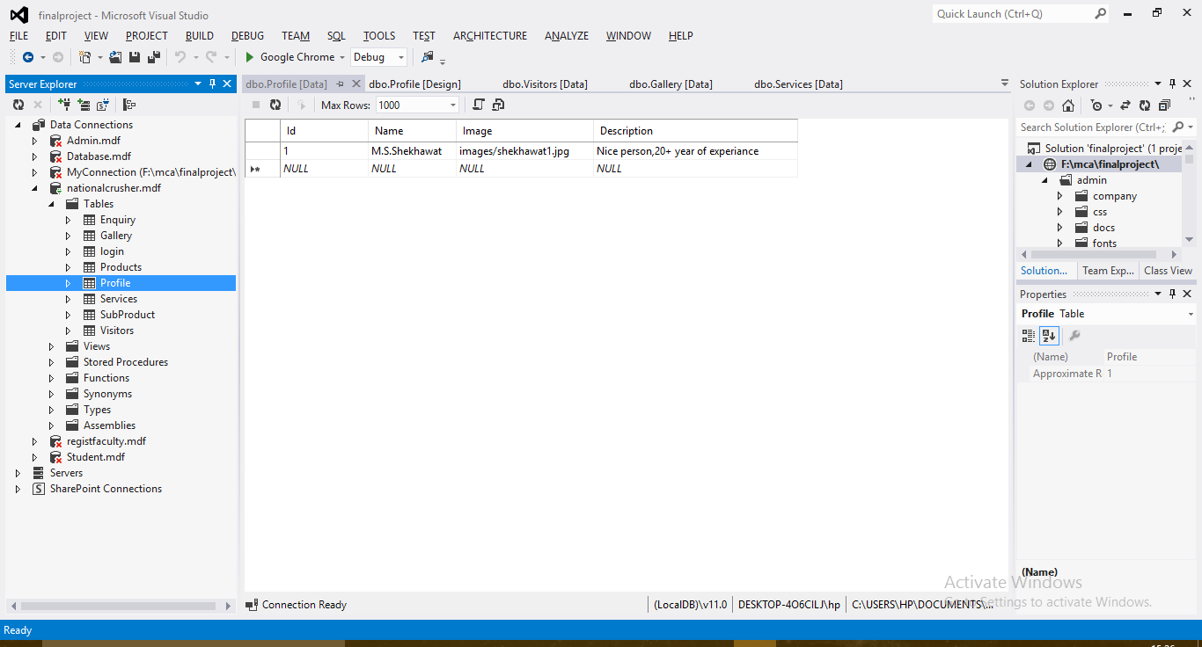

**SUBJECT**

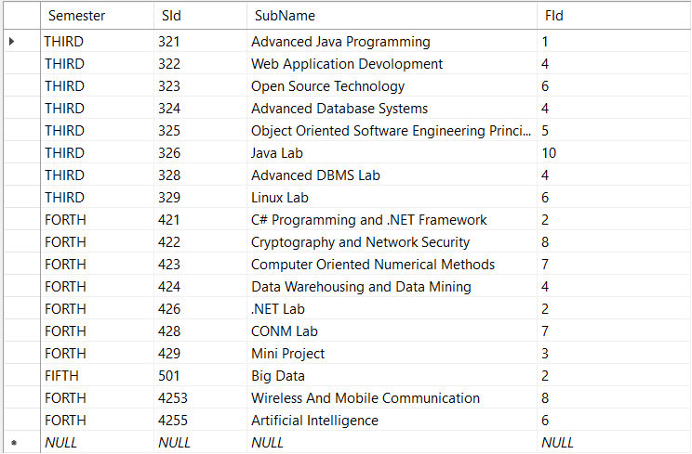

**STUDENT**

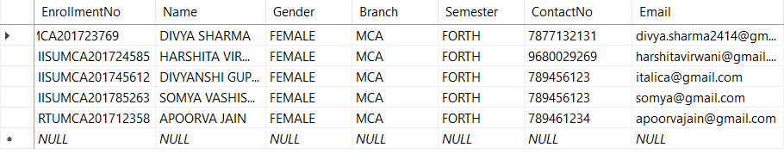

**RESULTS**

